TASK 1
protocol Payable {
var name: String { get }
func monthlyPay() -> Double}
extension Payable {
func payslip() {
print(name, monthlyPay())}}
struct Employee: Payable {
let name: String
let salary: Double
func monthlyPay() -> Double {
salary / 12}}
struct Intern: Payable {
let name: String
let salary: Double
func monthlyPay() -> Double {
salary}}
struct Contractor: Payable {
let name: String
let salary: Double
func monthlyPay() -> Double {
salary}}
let workers: [any Payable] = [
Employee(name: "Ravi", salary: 360000),
Intern(name: "Asha", salary: 10000),
Contractor(name: "Kiran", salary: 15000)
]

for worker in workers {
worker.payslip()}
OUTPUT:
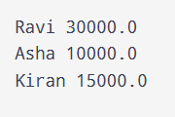

TASK 2
extension Int {
var isEven: Bool { self % 2 == 0 }
func squared() -> Int { self * self }
}
extension Array where Element == Int {
var sum: Int { reduce(0, +) }
}
extension String {
var wordCount: Int { split(separator: " ").count }
}
struct Version: Comparable {
let major: Int
let minor: Int
static func < (a: Version, b: Version) -> Bool {
if a.major == b.major {
return a.minor < b.minor
}
return a.major < b.major}}
print(4.isEven)
print(5.squared())
print([1, 2, 3].sum)
print("Hello World".wordCount)
let versions = [Version(major: 2, minor: 0), Version(major: 1, minor: 9)]
print(versions.sorted { $0 < $1 })

OUTPUT:
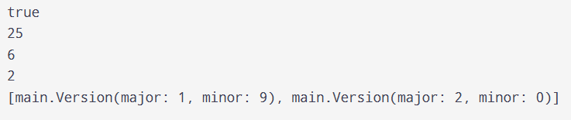

TASK 3
protocol Flyable {
func fly()
}

protocol Swimmable {
func swim()
}

struct Duck: Flyable, Swimmable {
func fly() { print("Flying") }
func swim() { print("Swimming") }
}

struct Eagle: Flyable {
func fly() { print("Flying") }
}

struct Fish: Swimmable {
func swim() { print("Swimming") }
}

func showOff(_ animal: Flyable & Swimmable) {
animal.fly()
animal.swim()
}

showOff(Duck())

OUTPUT:
